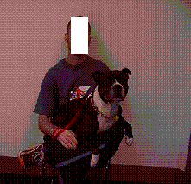


GPO Box 1998, Adelaide SA 5001
Telephone: 8303 0822

This card certifies that the person named hereon:

XXXX XXXXX
of X XXXX XXXX, XXXXXXX XXXX has permission for his dog ‘XXXXX’ to accompany him on all Adelaide Metro bus, train or tram services funded by the Passenger Transport Board.

This photo identification card must be:
- carried AT ALL TIMES when travelling;
(ii) produced to an authorised person on request in a declared area or when travelling on a bus, train or tram.

The dog ‘XXXXX’ may travel free of charge, whilst XXXXX XXXX when travelling on a bus, train or tram service is required to hold a valid ticket.

Expires 31/12/04

Heather Webster
Executive Director

